Nikki Shakeraneh September 24, 2024

040901133

Lab 3 (CST8912)

1. Create a storage account “labtest8912” under student subscription and resource group “CST8912-demo” for region Canada central and select geo redundant storage (geo redundant storage GRS), keep networking and data protection options default

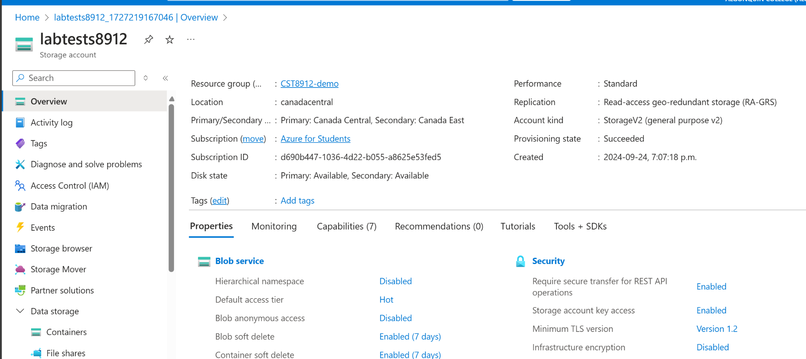

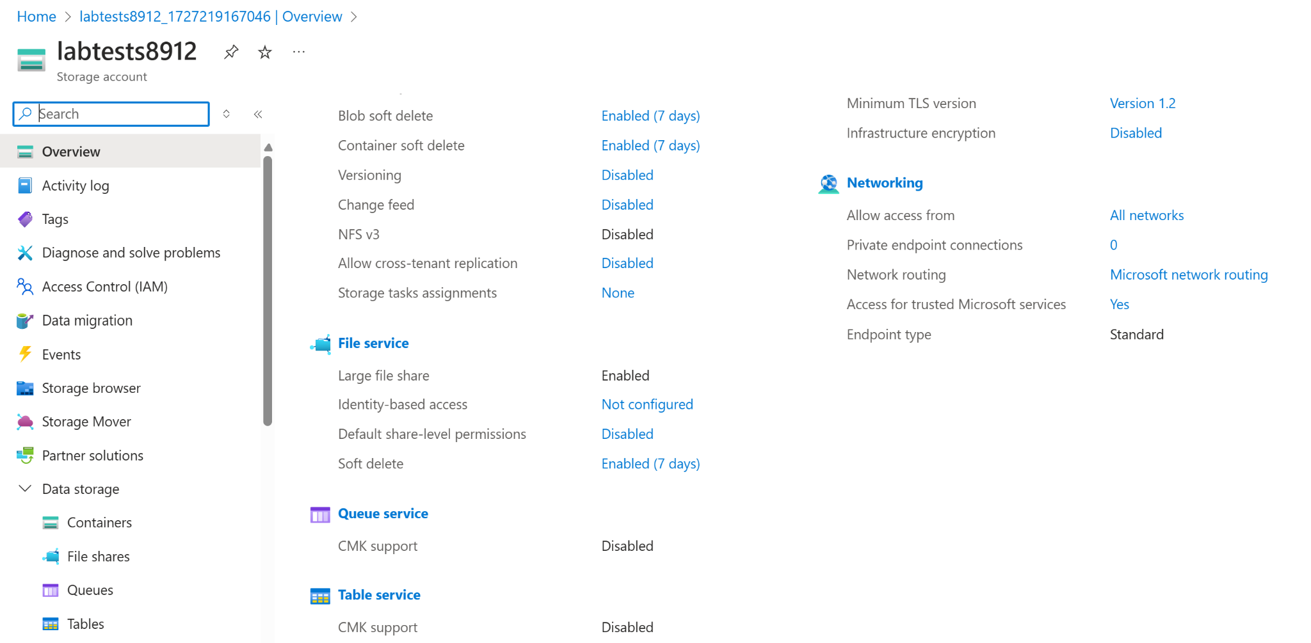

2. Go to your storage account resource blade, in data management section, go to redundancy tab and change redundancy to “local redundant storage” from dropdown, and under settings choose configuration and set blob access tier to cool and save the change

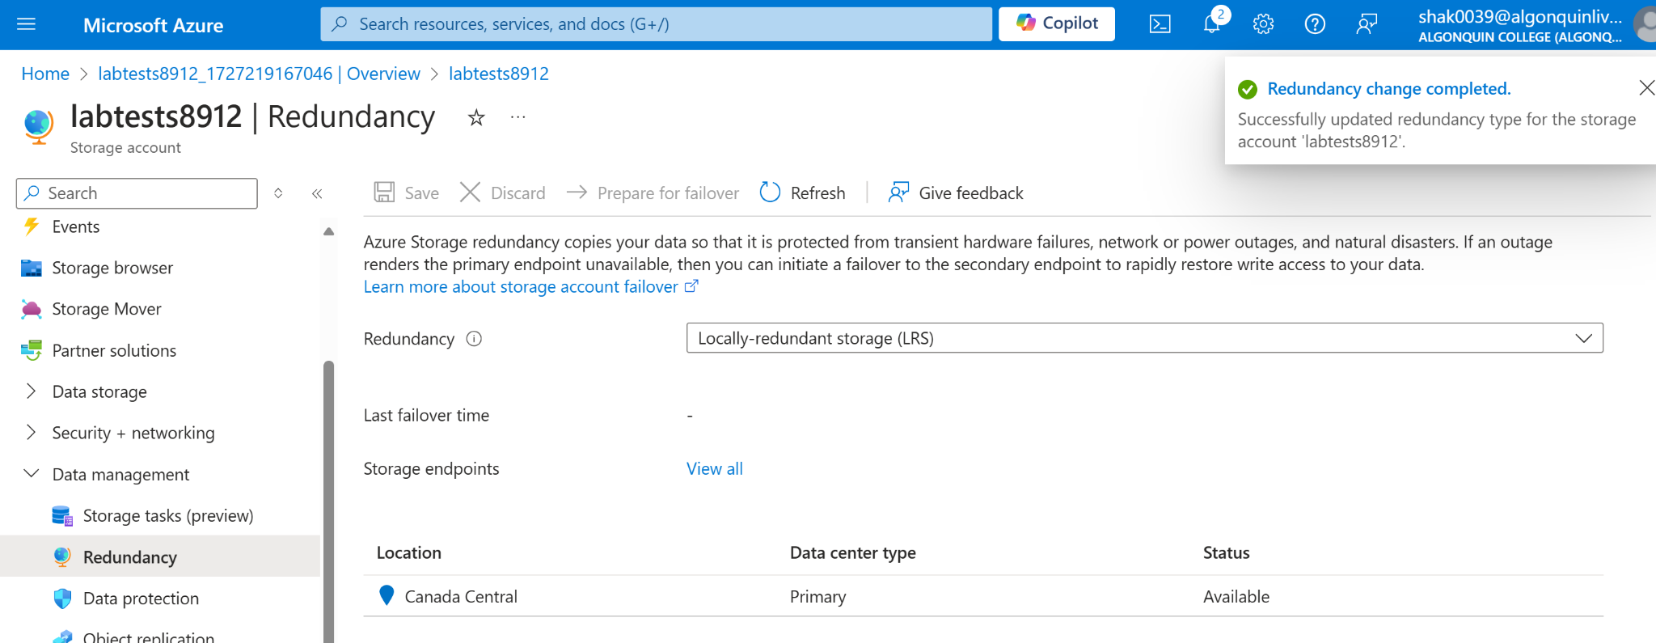

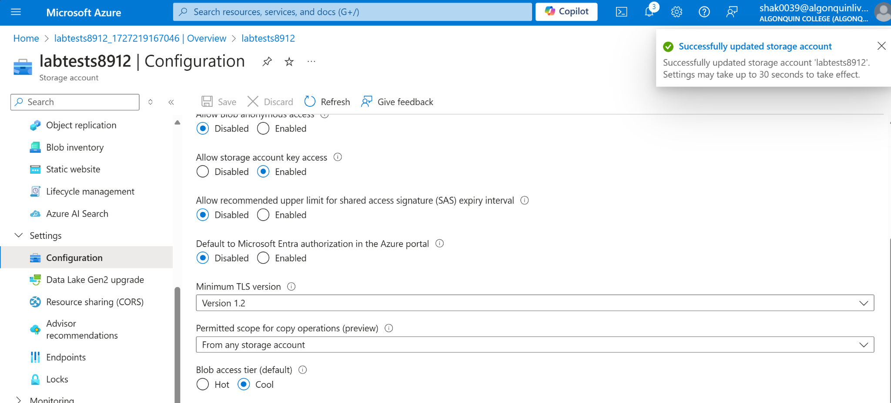

3. under data storage in left, click containers and add new container named “labtestcontainer8912” and select upload a blob and change the advance settings and change the access tier to “hot” and upload to folder named “sampletest8912”, browse the files from the sample files links shared in this lab (check with your instructor if you cannot find the sample file link)

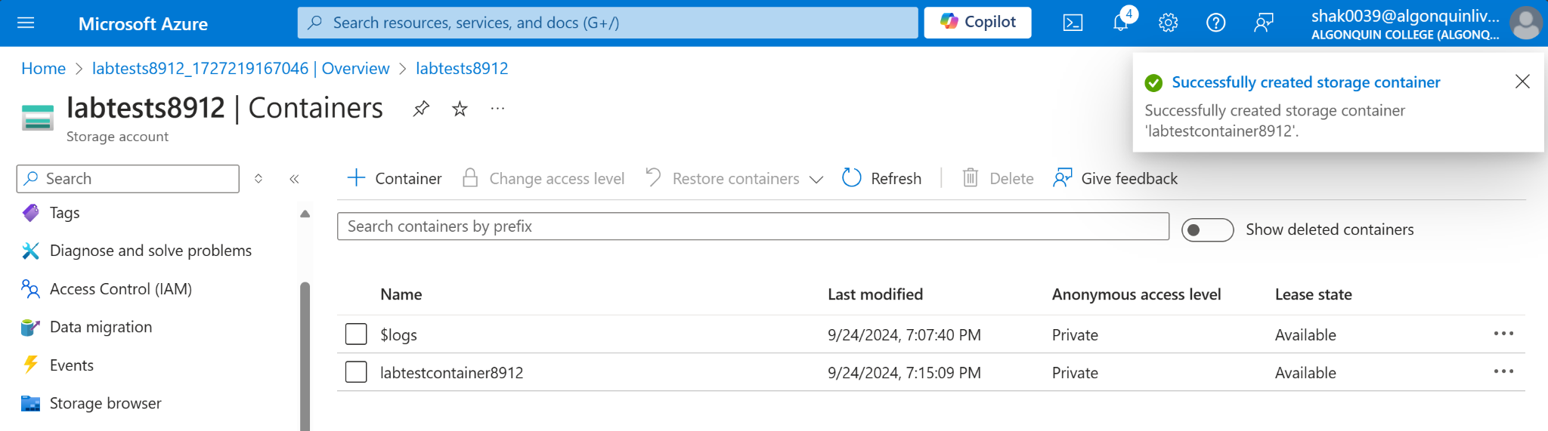

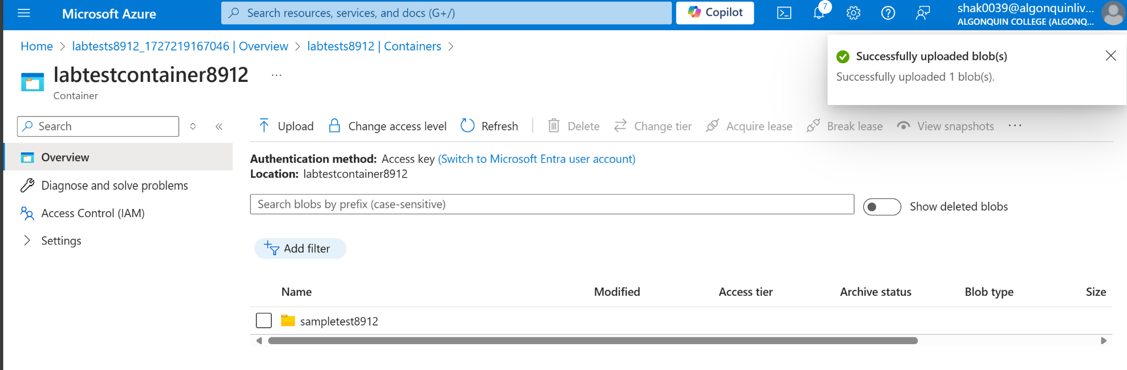

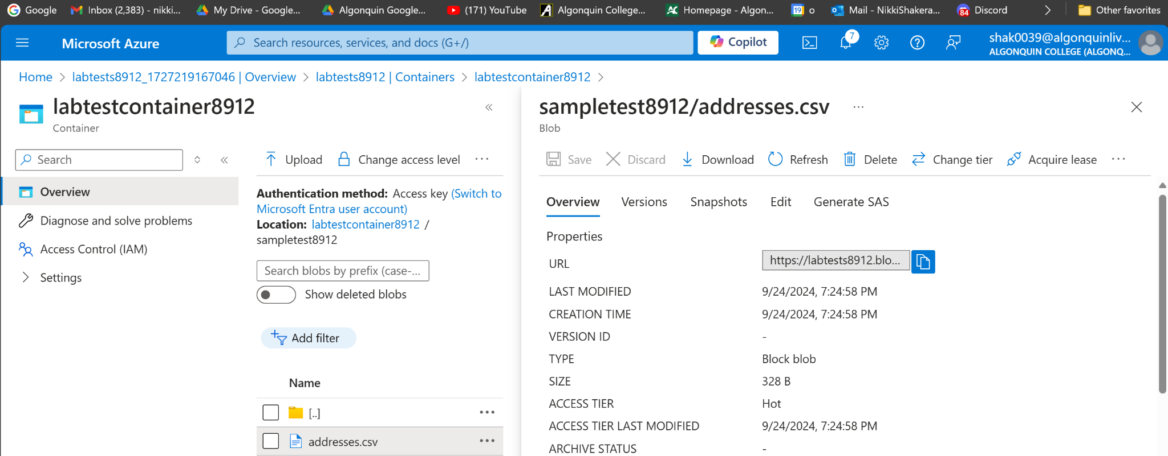

4. click the file uploaded in the container to see the configuration options and copy the blob url and open a new private window from the browser to paste the copied url.

note : The url should not work since the containers public access is set to private, resource was not found.

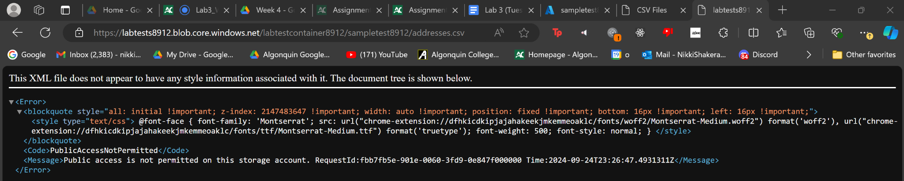

5. On the file blade, click generate SAS and copy the SAS token generated and paste the blob SAS URL on the private window of the browser, you must be able to see the file /3

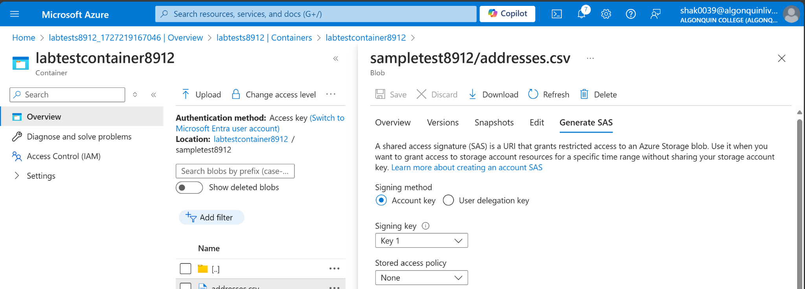

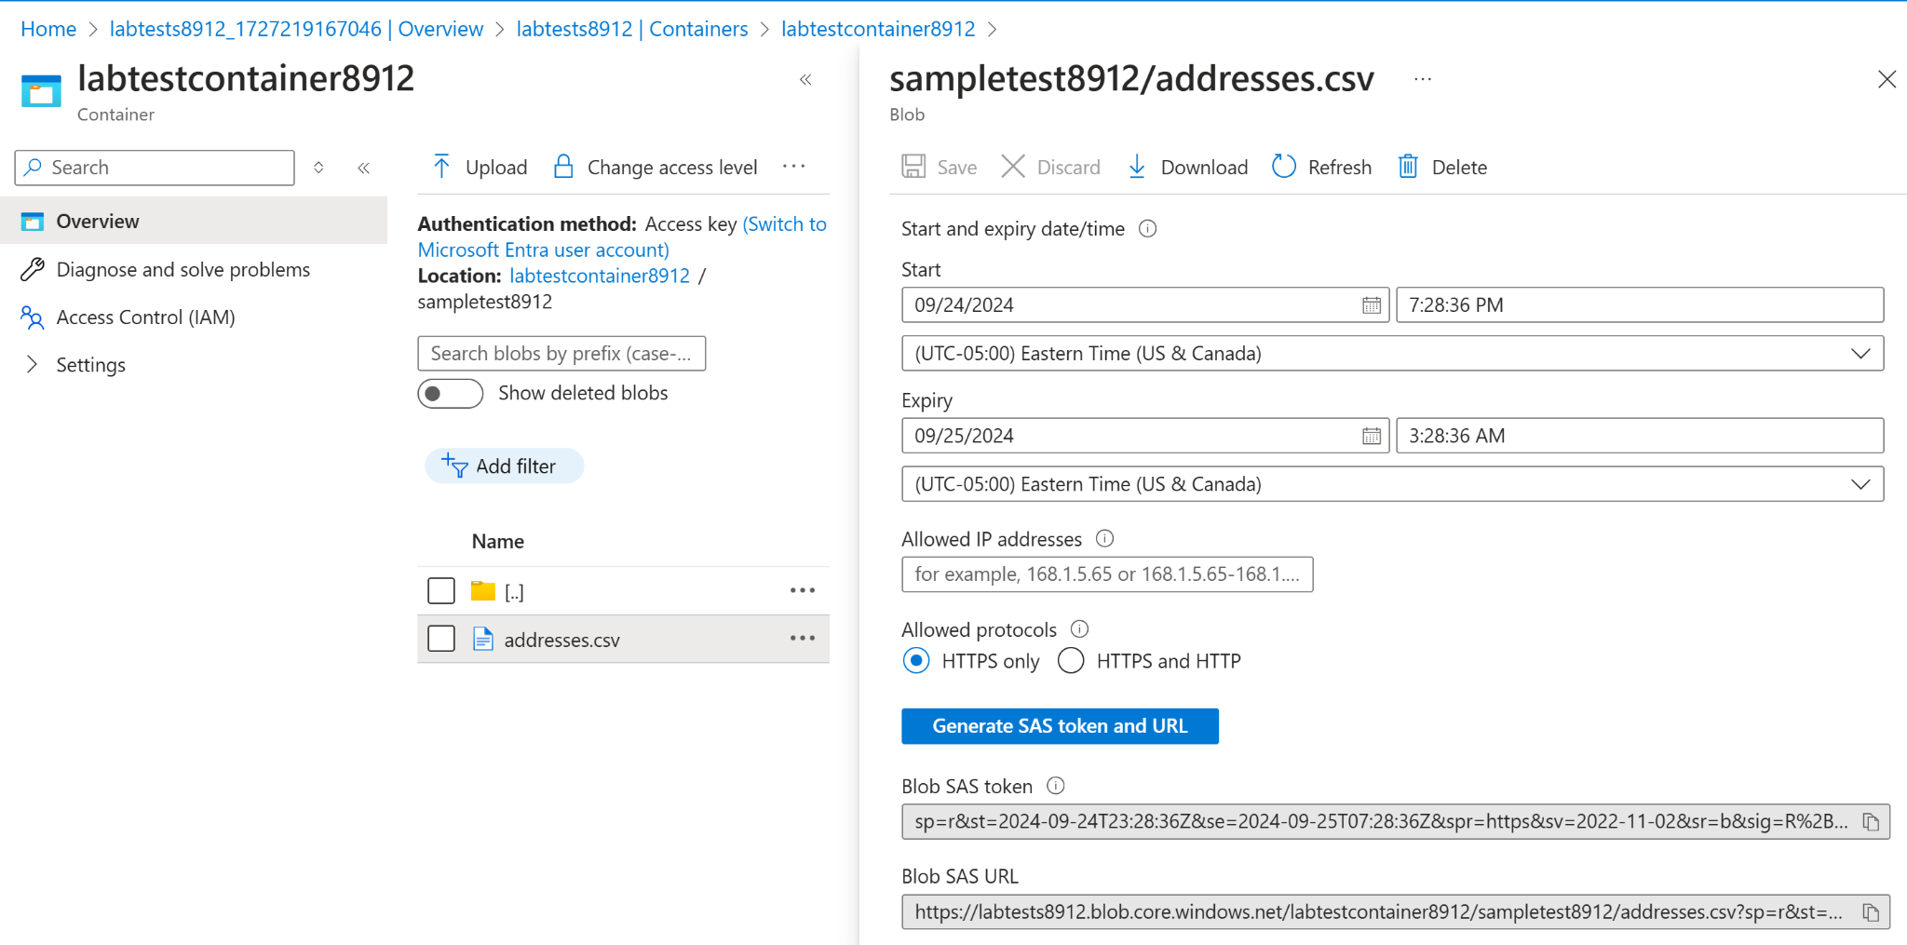

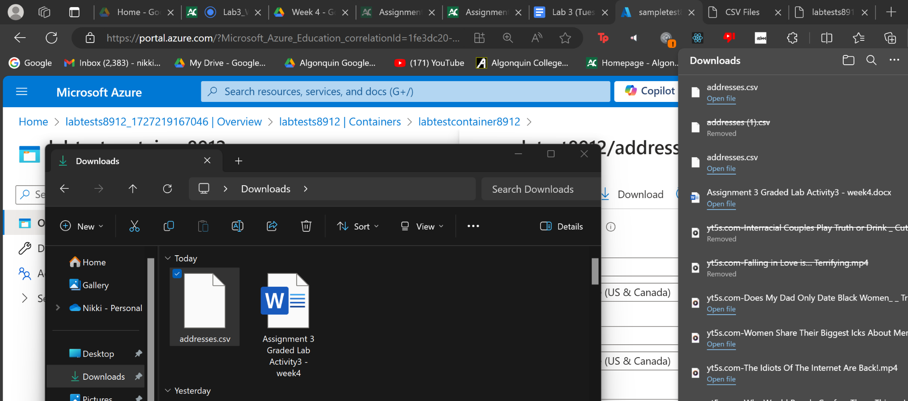

6. On the container blade under data management tab go to “Lifecycle Management” and create a new rule name “myrule8912”, rule scope should be “limit blobs with filters” and blob type and blob subtype should be default, add condition if base blobs were last modified more than “ 15 days” ago then “move to cool storage”

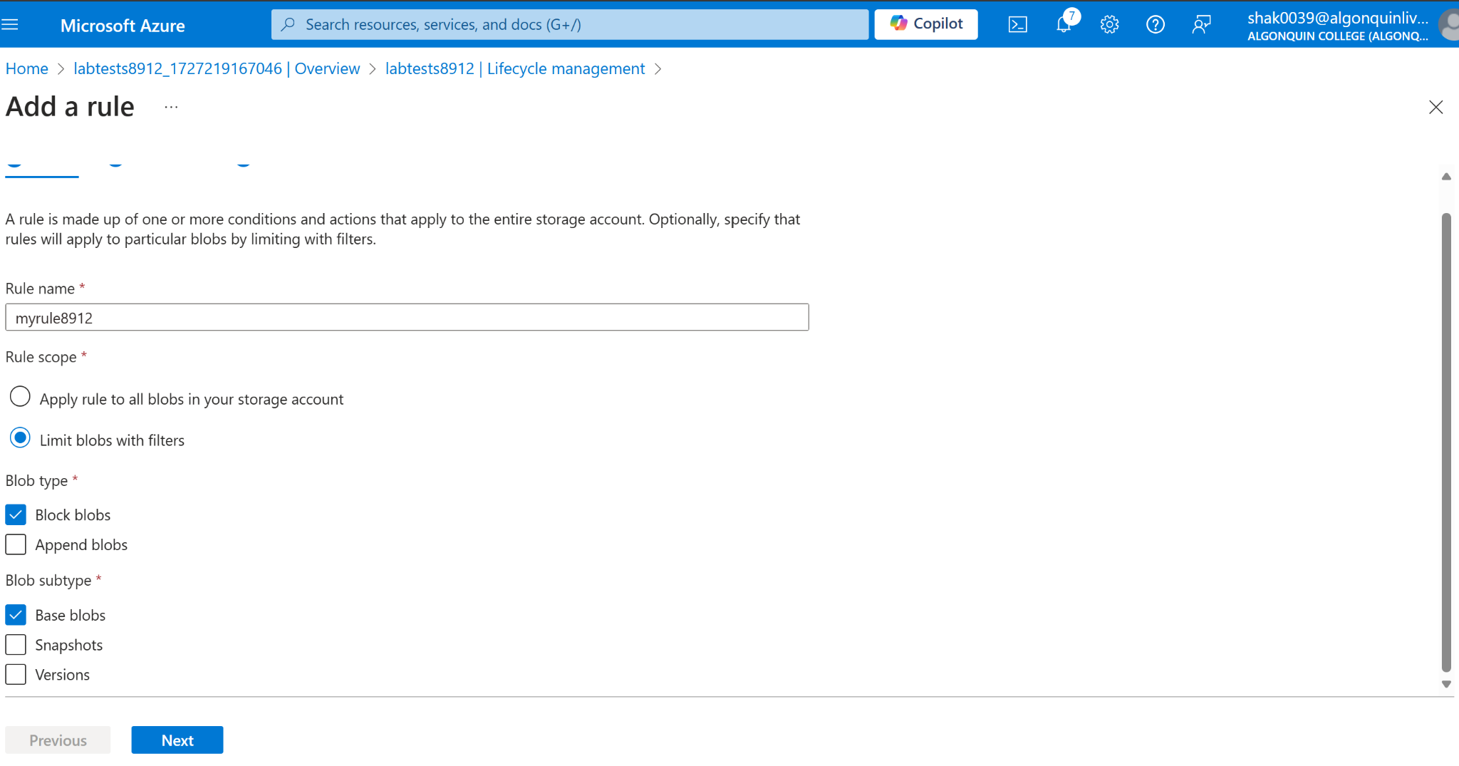

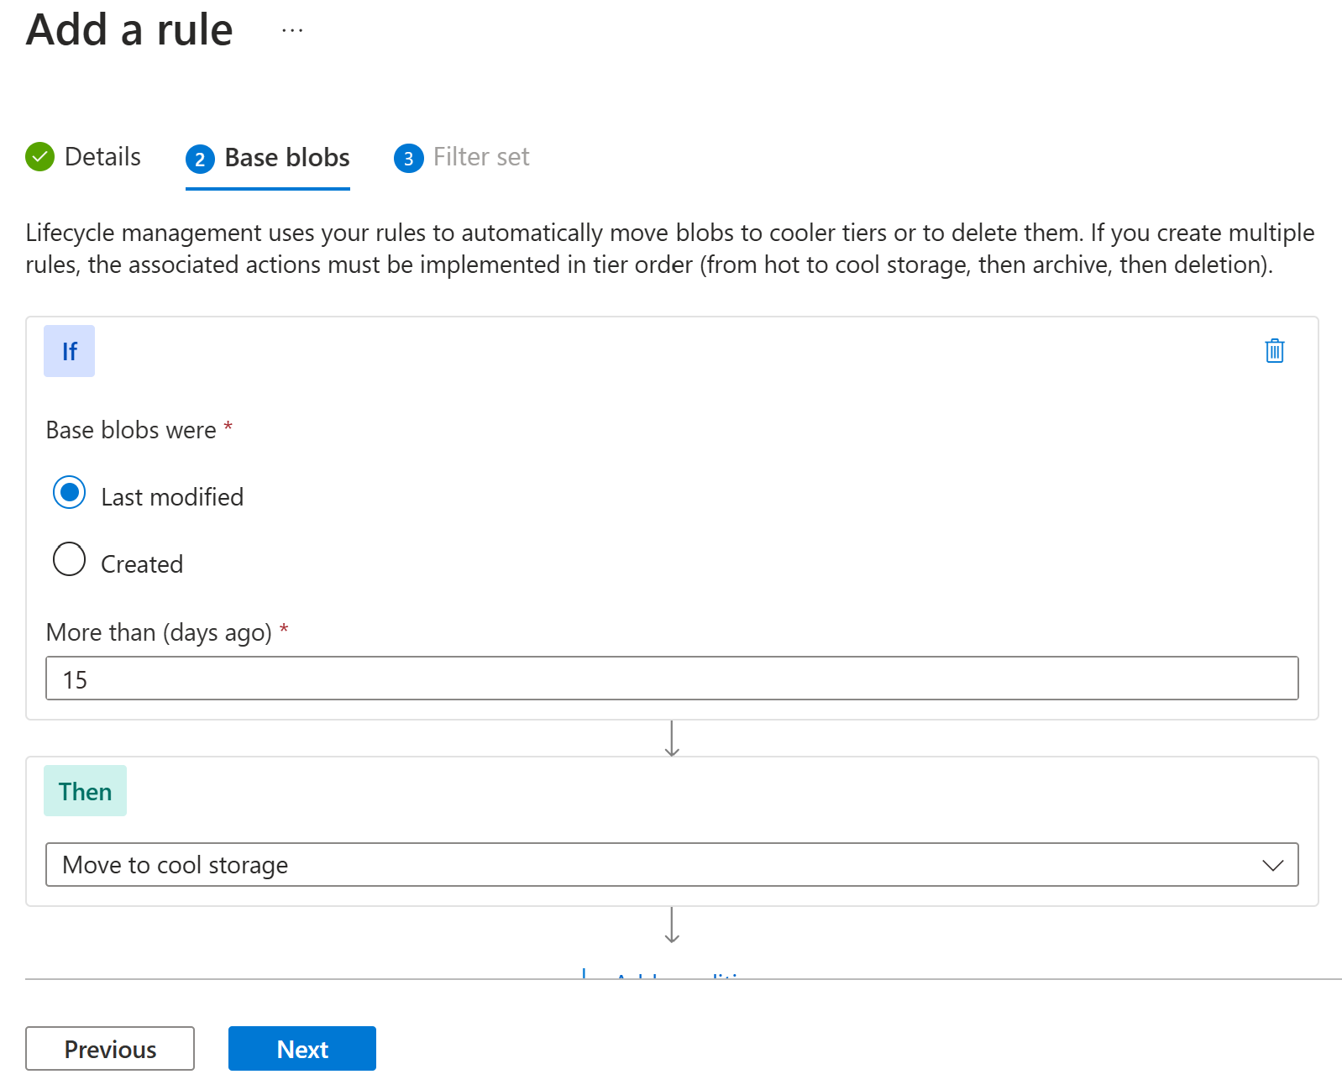

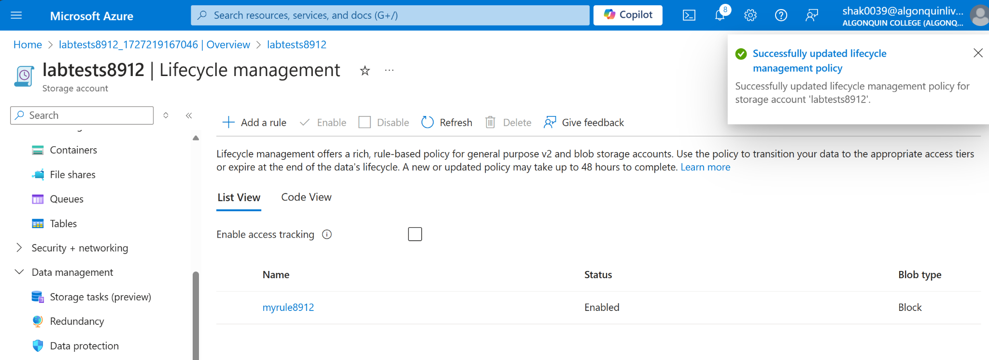

After demo delete all the resources created during lab and create a lab report documenting all the steps with screenshots

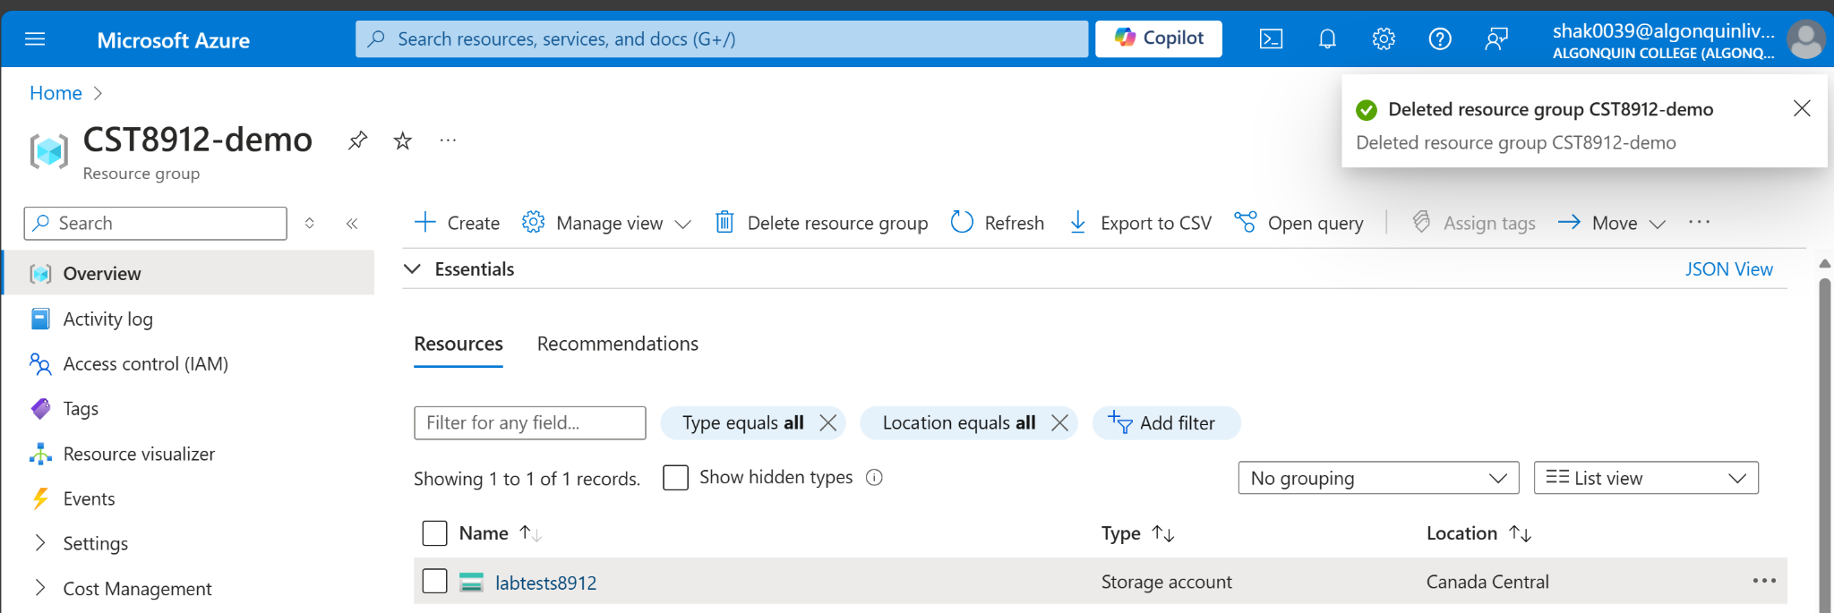

**Lab Report**

In this lab, I learned how to create an Azure storage account and shared access signatures for Azure Cloud, as well as being able to change the rules for managing a lifecycle of cloud storage. I found that these topics were incredibly important, because there are many organizations across the world that use cloud services every single day, and it is important they each require different solutions for storing data in order to fit their specific business model. Many of these companies must keep track of huge amounts of data and Azure Storage is absolutely essential for growing their applications. This is incredibly important, because of the various types of data that are used for solutions, such as blobs, files and queues.

When Shared Access Signatures are generated, it allows the organization to have complete control over their resources. They can specify which actions are permitted, such as reading, writing or deleting data structures, and it allows the account to remain secure. The benefit of creating Lifecycle Management Policies, is that it allows the company to properly manage data, by specifying the age of the blobs, the blob types and the access tiers,